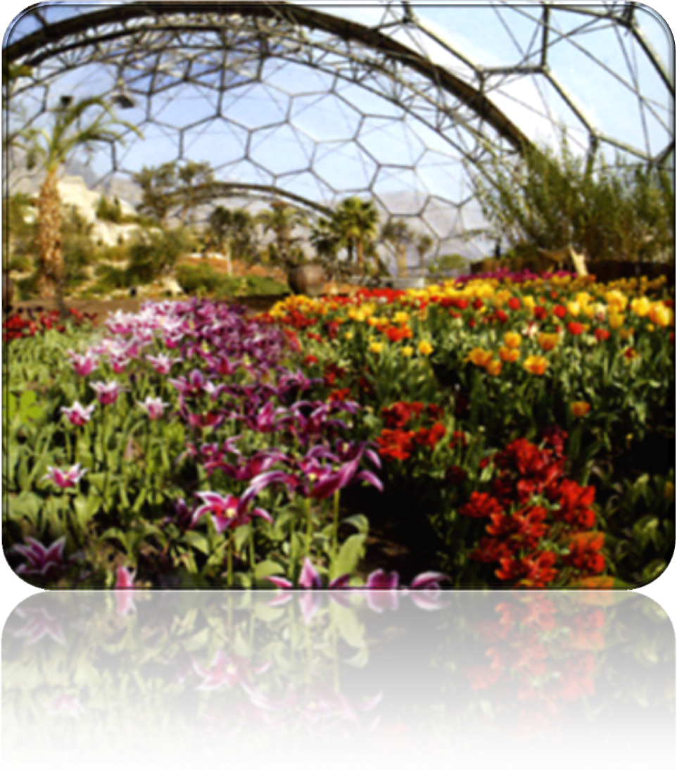

**Terrariums**

**Science  
Technology  
Engineering  
Maths**

*Namess*

_______________________

_______________________

_______________________

**Design Brief**

Your task is to design and produce a plant terrarium. Your design should be a product that could be marketed and sold by garden centres, it should therefore be pleasing to look at, easy to maintain and last for a long period of time

In designing your terrarium you should think about the following things

* What will your terrarium look like?
* What colour will the acrylic be?
* How will it be constructed?
* How will the plants survive?
* What plants will be grown in your terrarium?

You will be competing for prizes in the project, not only for the best terrarium, but also the best portfolio of evidence that supports your design decisions.

It’s up to you how you present your portfolio of evidence. You can use this booklet as a starting point; however your finished article could be a display or other visual method that could be presented to the judges

***Over to you!!***

What will your terrarium look like? You might like to find some examples of other terrariums on the market

How do Terrariums work??

How will the colour of the acrylic affect the plants and the way they photosynthesise?

What plants should you use in your terrarium?

What layers of compost will you need in your terrarium?

What shape tessellating shapes will your terrarium be made from? Are there any shapes that are better than others? Are there any shapes that are sued in nature? Why?

How will your terrarium be constructed? What materials will you use to join the shapes together?