So, firstly, I worked out how many tiles the square has (121) as it would be the maximum number of tiles to walk on.
Then, I used a zig-zag pattern (as shown below) to walk on the square until I met a corner.
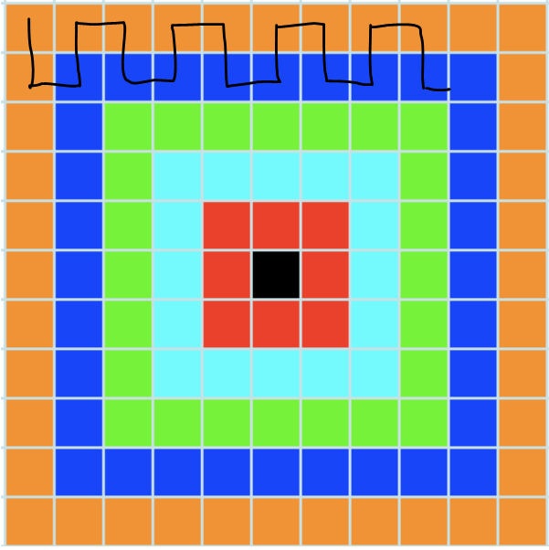
When I met a corner, I just realised that in order to walk on the maximum number of tiles, I couldn’t use the zig-zag pattern as I did earlier because then I would have to walk on a same coloured tile more than twice.
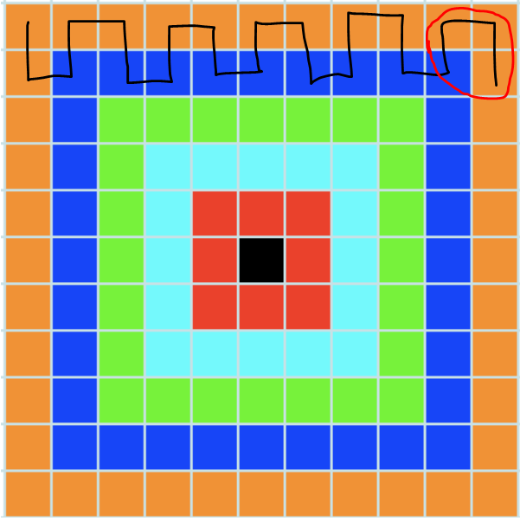
So, after many attempts, I found the solution (shown below). As I wanted to use all the tiles, I did not leave any of the tiles without walking on them.
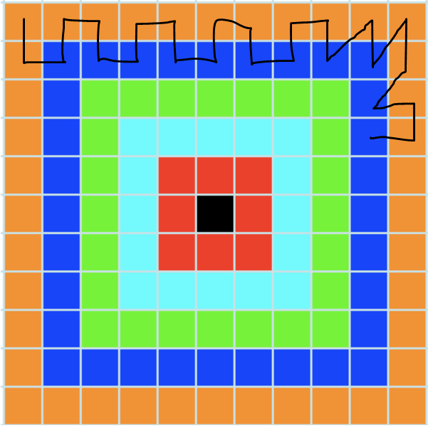
Then, I decided to use the zig-zag pattern again and then the diagonal pattern until I reached the green coloured tiles.
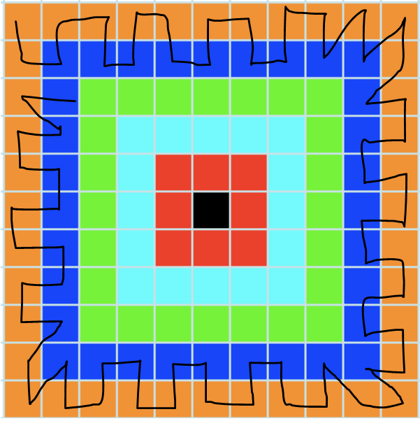
When I reached the green coloured tiles, I thought about how I can
in such a way that I don’t break any of the rules and use the
maximum amount of tiles. After a bit of thinking, I found this
solution.

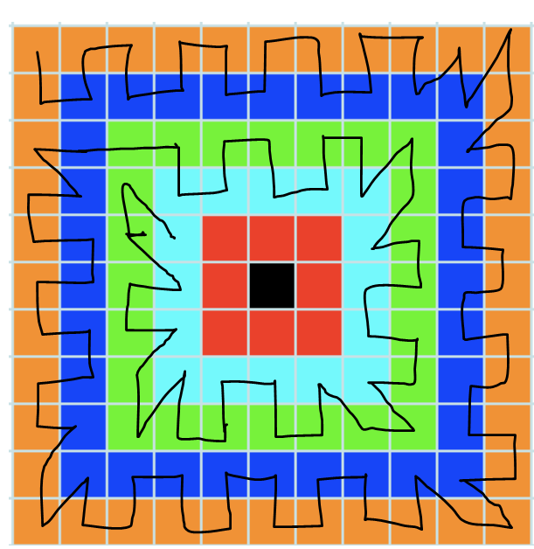
Suddenly, I realised that I have done a huge mistake. I realised that
I will not be able to walk on any tiles which were as there is only 1
black square in the middle. Then, after I started again, I found the
final solution.
