Rudolph's nose glows because it is home to a species of bacteria, Aliivibrio Rudolphi, that luminesces when it reaches a certain population density. It detects the size of its population by a process known as quorum sensing.

Each bacterial cell releases a signal molecule, X, at a rate of 1 molecule per minute and if the concentration of X is greater than or equal to 10¹¹ molecules per ml, the bacteria will glow. X decays with a half-life of 10 minutes, but the bacteria divide every 30 minutes.
Sadly, Rudolph catches a nasty cold, which, by the time he is better, has killed all of the bacterial cells in his nose except for one. Santa is worried: there are only 24 hours left until they need to set off to deliver Christmas presents. Will Rudolph's nose be glowing again in time?
If you need any data that is not included, try to estimate it: Santa wants an answer now, so that he can make alternative plans if need be.
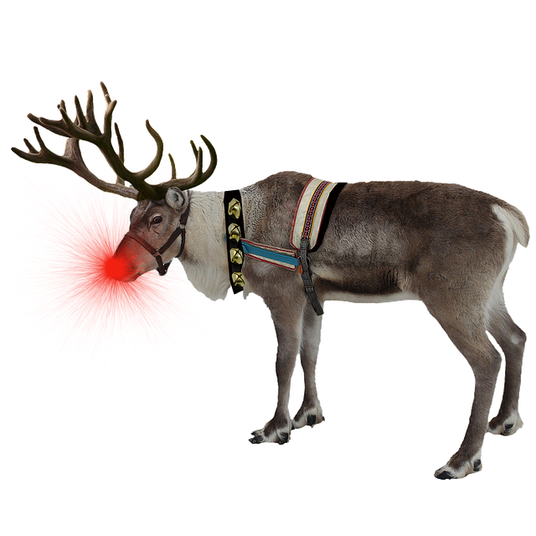

Rudolph's nose glows because it is home to a species of bacteria, Aliivibrio Rudolphi, that luminesces when it reaches a certain population density. It detects the size of its population by a process known as quorum sensing.

Each bacterial cell releases a signal molecule, X, at a rate of 1 molecule per minute and if the concentration of X is greater than or equal to 10¹¹ molecules per ml, the bacteria will glow. X decays with a half-life of 10 minutes, but the bacteria divide every 30 minutes.
Sadly, Rudolph catches a nasty cold, which, by the time he is better, has killed all of the bacterial cells in his nose except for one. Santa is worried: there are only 24 hours left until they need to set off to deliver Christmas presents. Will Rudolph's nose be glowing again in time?
If you need any data that is not included, try to estimate it: Santa wants an answer now, so that he can make alternative plans if need be.

