CUBE PROJECT

To do this project, we had to work in teams. We decided that each person would do one or two cubes each. We decided to use nets to make our cubes. The card we were using already had squares printed on it to make it easier.
We learned how to make nets of different 3D shapes with our math teacher. To make them easier for us to stick together, we included tabs.

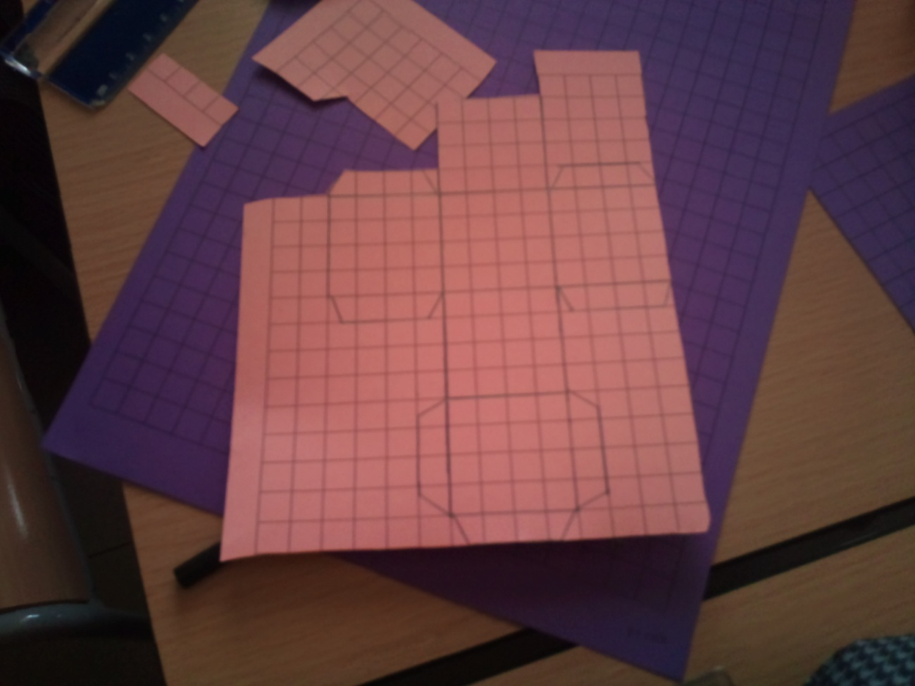
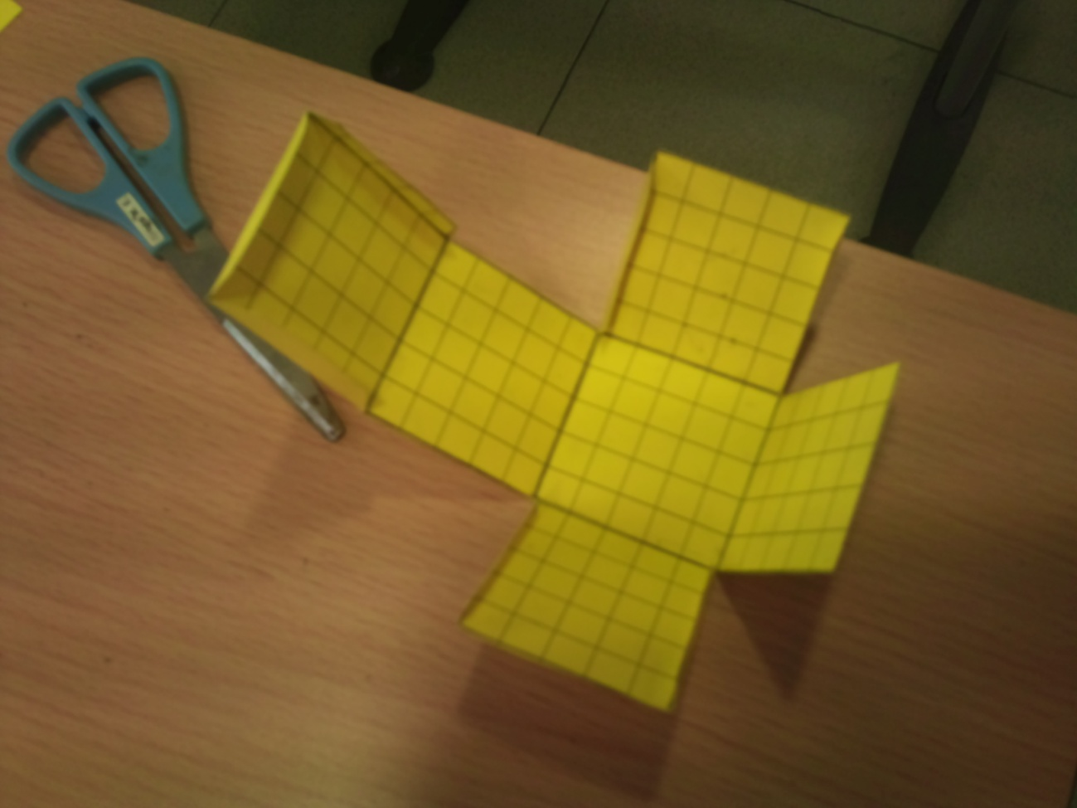

The first one we finished was the cube with a volume of 1cm³, the smallest one. It was tiny, and we kept dropping it on the floor. It was also the hardest one to stick together with glue, so we used a bit of sellotape. For the larger cubes we had to make the nets in 2 parts.

After we had finished all of them, we had to calculate the volumes of each cube. We used the formula length x width x height. Here are our calculations:
- 1x1x1=1 cm³
- 2x2x2=8 cm³
- 3x3x3=27 cm³
- 4x4x4=64 cm³
- 5x5x5=125 cm³
- 6x6x6=216 cm³
- 7x7x7=343 cm³
- 8x8x8=512 cm³
- 9x9x9=729 cm³
- 10x10x10=1000 cm³
Something interesting that we noticed is that the smallest cube fits into the largest one a thousand times. Also, although 8 is close to 10, the volume of 8 cm³ is nearly half that of 10 cm³.
Here are our finished cubes.
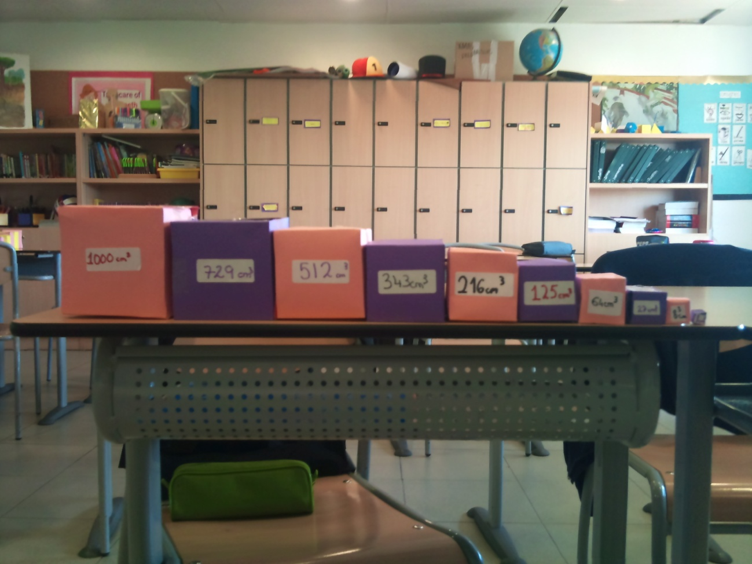
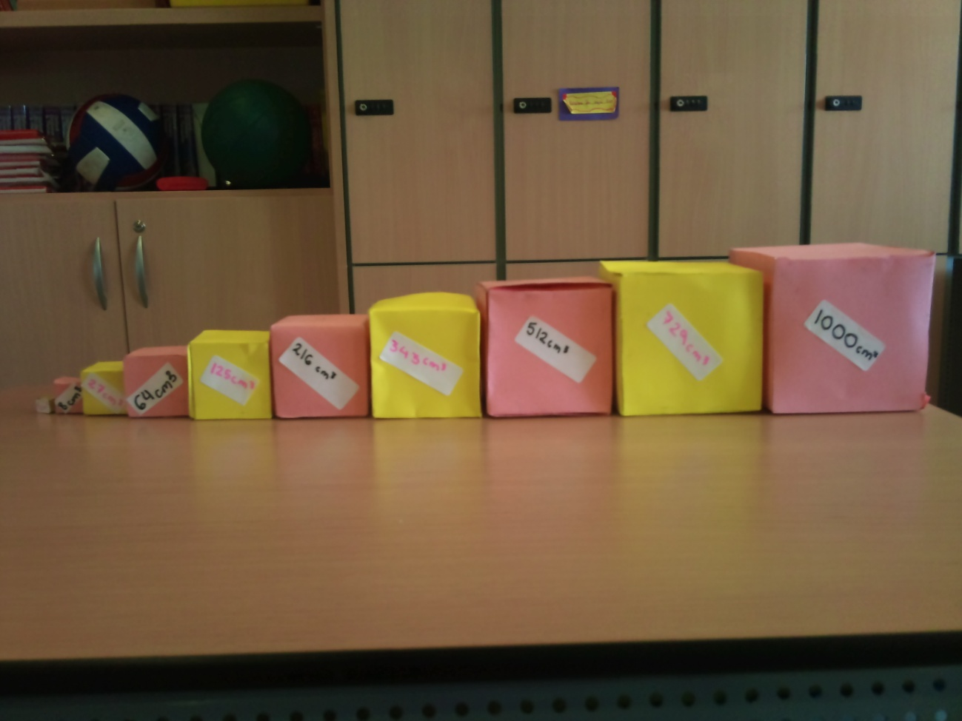
(Kristina, Aisha, Irina, Clara, Maria, Adriana, Jorgina, Laura, Judith, Isabel F, Isabel V, Irlanda, Samantha)

