Consider a right angled triangle with an acute angle of θ. Let the base of the triangle be of length 2.
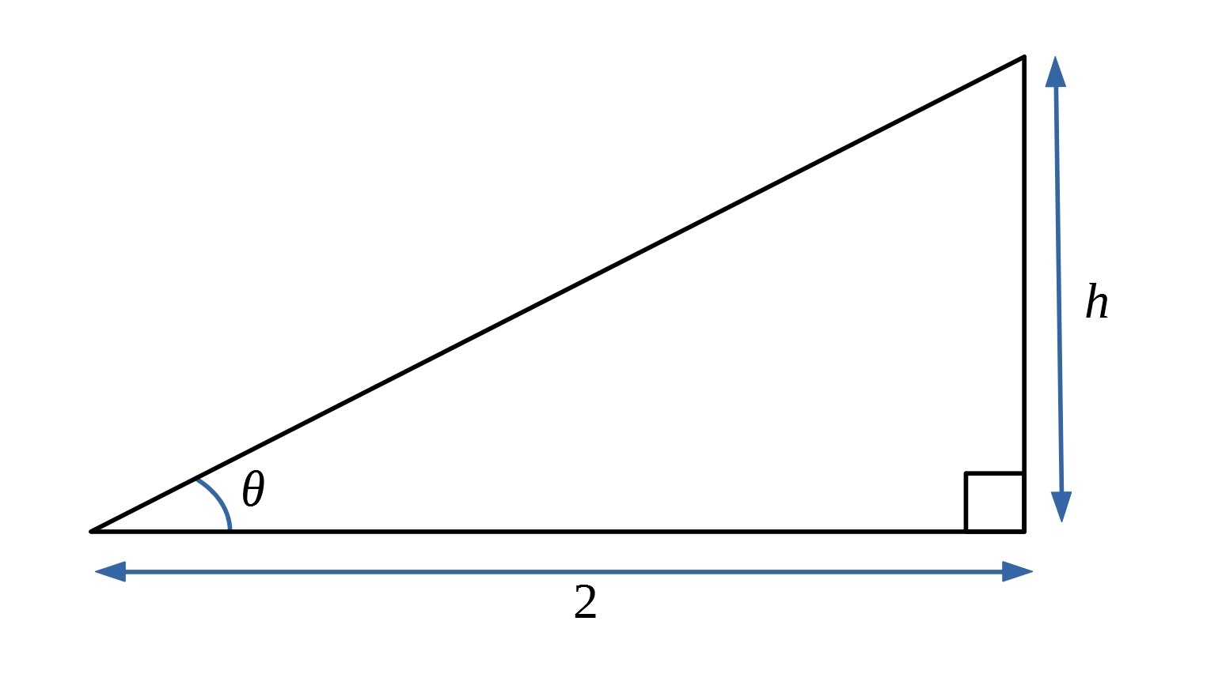
Find the height of the triangle in terms of t, where t = tan θ.

Now imagine a line in the triangle which forms an isosceles triangle with two angles equal to θ.
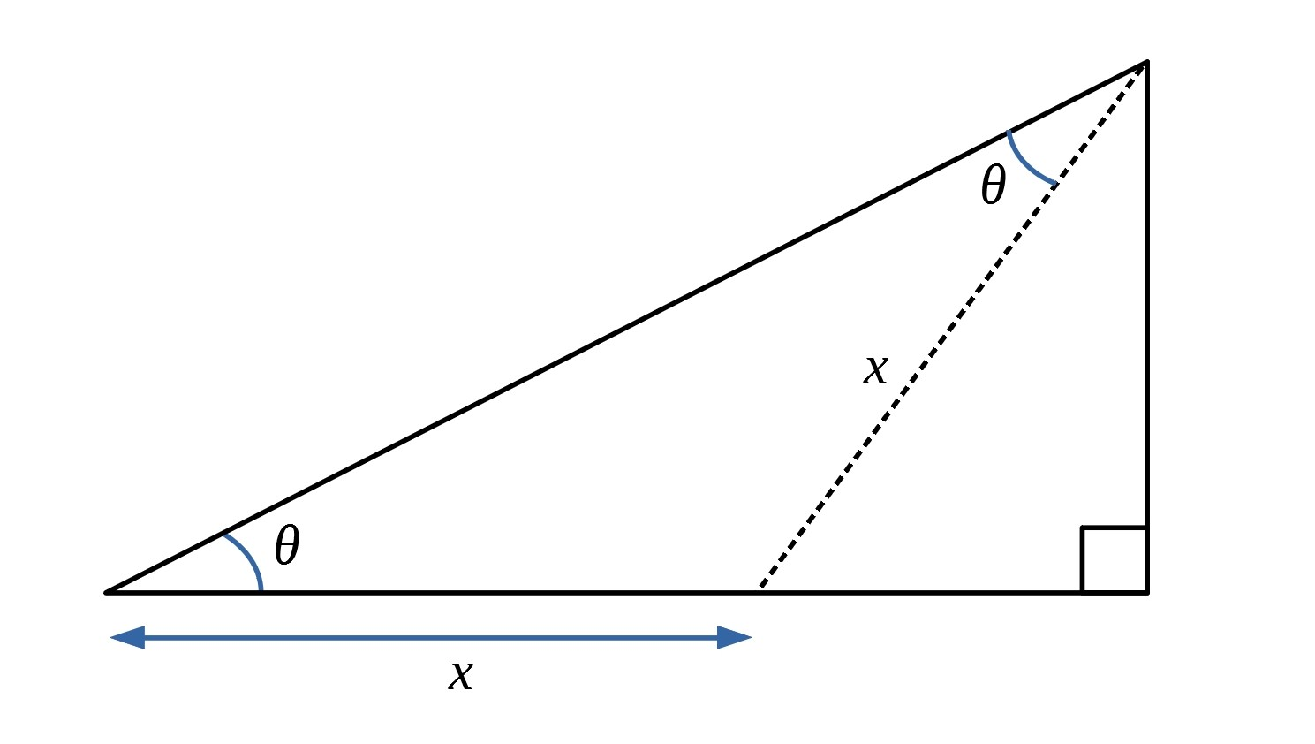
Use this diagram to prove the double angle formula, where t = tan θ:
$\tan{2θ=\frac{2t}{1-t^{2}}}$, $\sin{2θ=\frac{2t}{1+t^{2}}}$, $\cos{2θ=\frac{1-t^{2}}{1+t^{2}}}$

