For this task, imagine using a number of rods, each with a length of 1 unit.
You will use the rods to create a letter U shape which is symmetrical.
Example 1:

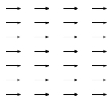 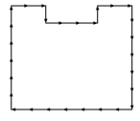 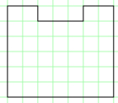
28 rods U shape Area of 39 square units
Example 2:
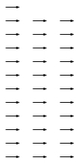 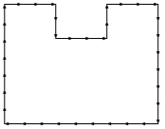 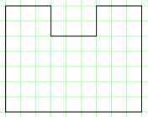
34 rods U shape Area of 57 square units

The following are not allowed as they are not U-shaped:
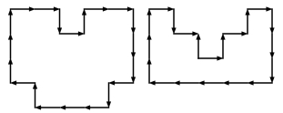

Challenge 1
Using 20 rods find one U shape which has an area that is an even number of square units and one which has an area that is an odd number of square units.

Challenge 2
Using any number of rods find a U shape with an area of 14 square units.
Can you find all the U shapes with an area of 14 square units?
How do you know you’ve got them all?

