1/Apex Primary
Tajrin: One of the numbers in the adding equation is divisible by three and so the answer (total) will be in the three times tables.
4 odd numbers make an even total because the answer will be divisible by 4. for example, 5+7+9+11=24, which is divisible by 4.

Izma: You get these patterns that go up in the 3 times tables and are odd because the 3 times tables have a pattern that if 3 is being multiplied by an odd number, the result will be odd, and vice versa for even numbers. In this pattern, we're adding three odd numbers, so it falls into place with the three times tables.

Aasiyah: When adding 5 consecutive odd numbers. Whatever the middle number is, when you times it by 5, it will be the answer of all the 5 numbers added together.
e.g., 1+3+5+7+9=25, and 5 times 5 is 25. 5+7+9+11+13=45, and 9 times 5 is 45.
Sumaiyah: If you start an equation dropping the first used digit in a 5 consecutive odd sum, the answer will always be 10 more than the previous answer. for example, 1+3+5+7+9=25 3+5+7+9+11=35
- - - - - - - - - - - - - - - - - - - - - - - - - - - - - - - - - - - - - - - - - - - - - - - - - - - - - - - - - - - -

2/Bassingbourn Primary
Rowan: Three odd numbers added together make another odd number. Because, two odd numbers added together make an even number. So, if you add an odd number to an even number you get an odd number.
Sequence adds 6 each time when you move one odd number up the scale because you are adding two to each number which is a total of 6. E.g. 1 + 3 + 5 = 9 +2 +2 +2 3 + 5 + 7 =15

Sailfish: When you add 2 odd numbers it will always make an even number, therefore if we add another odd number it will always be odd. If you add 5 consecutive odd numbers it will always be an odd number. When you add 4 consecutive odd numbers you will always get an even number. When you add 3 consecutive even numbers, if you times the middle number by 3 you always get the answer, they are all in the 6 times table. When you get 5 consecutive odd numbers they all go up in 10 starting from 25.

Lexi: First number and last number in sequence have a total which is in the 3 times table. The middle number is always in the three times table so it will always be a multiple of 3.

Lexi and Florence:The number of consecutive numbers (when an odd multiple) will give the
answer when multiplied by the middle number. 1 +3 + 5 = 9 (3 x 3)
1 + 3 + 5 + 7 + 9 + 11 = 25 (5 x 5)

Hanah: I think that if you add 5 consecutive number together the answer will be odd because you are adding and odd amount of numbers. If you were to add an even amount of number (e.g 4) the answer would always be even because you are adding an even amount of numbers. :)
- - - - - - - - - - - - - - - - - - - - - - - - - - - - - - - - - - - - - - - - - - - - - - - - - - - - - - - - - - -

3/Berlin Brandenburg International School
Do Kyung AND Noah

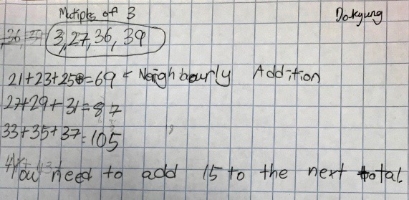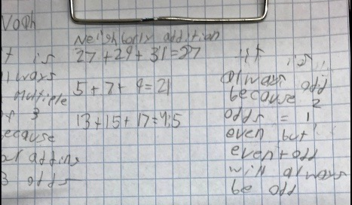

Amaan :

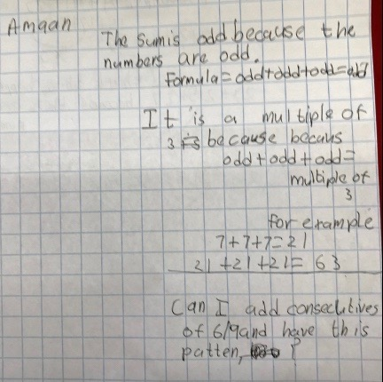
- - - - - - — - - - - - - - - - - - - - - - - - - - - - - - - - - - - - - - - - - - - - - - - - - - - - - - -

4/Bishops Down
Pine Class: We have been working in pairs to find their answers. We noticed that our totals will always be an odd number. Some examples of what we did were:
21+23+25=69 33+35+37=105 13+15+17= 45 123+125+127=375
Scarlett, Isabella and Naiana have discovered that when adding three consecutive even numbers the answers go up in 12s, if you carry on from the last number. E.g. 2+4+6=12 6+8+10 = 24 10+12+14 =36

Jameela and Alex discovered that when adding three consecutive even numbers. the answer will still be three times the middle number.

Willow and Haris did 5 consecutive odd numbers. They found that they got even numbers as their answer. We have checked this as a class and found that it is always correct.

Oak Class: We have found out that when you add three odd numbers together the answer will always be odd. If you add two odd numbers together, the answer will be even for example, 1 + 3 = 4. If you then add another odd number to the total the answer will be odd e.g. 4 + 5 = 9. If you look at the three consecutive odd numbers e.g. 7 + 9 + 11, we have noticed that 7 + 11 = 18 which is 9 x 2. If then you add 9 to this answer you get 27 which is 9 x 3.
Also 7 is two away from 9 and 11 is two away from 9. Therefore 7 + 9 + 11 can be written as 9 + 9 + 9 which gives us 27 which is 9 x 3.
- - - - - - - - - - - - - - - - - - - - - - - - - - - - - - - - - - - - - - - - - - - - - - - -

5/Camblesforth

William: I noticed that when you multiply the middle number by 3, you get the correct answer. To check this, I tried 363 + 365 + 367 = 1095. I could predict what the answer would be.
re always in the 3 times tables and the 6 times tables, because all multiples of 3 are also multiples of 6.
I tried adding 5 consecutive odd numbers and the middle number multiplied by 5 gave me the answer! I wonder if they work for other patterns?
I tried adding 5 consecutive even numbers and the same pattern worked (multiply the middle number by 5)

Will: I noticed that 7+9+11=27 and 15+17+19 = 51. Then, when I x 17 by 6 I had 102. Then I halved this, and the answer was 51.

Josh: I think that because there are 3 odd numbers, they will always give an odd number when you add them together. If you added 2 odd numbers, they would give you an even number, but adding 3 always gives you an odd number.

Connor: When you add three even numbers, the answer is always in the 3 x tables. The answer will also always be an even number.
- - - - - - - - - - - - - - - - - - - - - - - - - - - - - - - - - - - - - - - - - - - - - - - - - - - - - - - - -

6/Castle Academy
6AT all answers are odd all answers are in the 3 times table
We discovered that adding 3 even numbers have the same result
We discovered that if you have 5 or 7 consecutive numbers it still works and the middle number is 5 or 7 times the amount.
- - - - - - - - - - - - - - - - - - - - - - - - - - - - - - - - - - - - - - - - - - - - - - - - - - - - - - - - - - - -

7/Castle School
Castle4J
Answers are odd numbers.
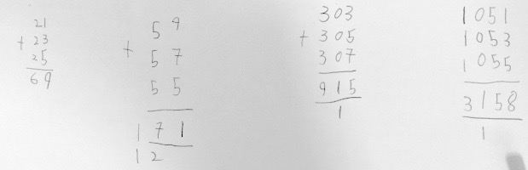
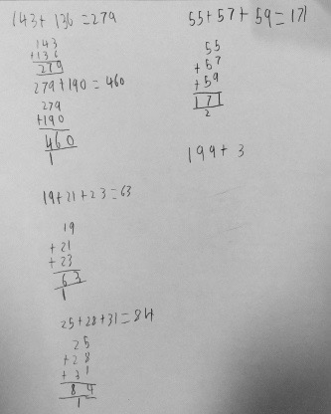
- - - - - - - - - - - - - - - - - - - - - - - - - - - - - - - - - - - - - - - - - - - -

8/Chilton Primary
Sophie: All the answers are odd. There's a difference of 6 if you add them up consecutively.

Patrick: If the first number ended up 1, then the answer will be 9. If the first number ended with a 3, then the answer will be 5. If the first number ended with 7, then the last number in the answer will always be 7. If the first number ended in 9, then the first answer will always end in 3.

Lauren: If using continually consecutive numbers, the units go down in 2 (odd) and the tens go up in 2s (evenly).

Mercy + Gracie: In every calculation, there's always a number that's in the 3 times tables. In the middle of every calculation, you are multiplying it by 3. If you move 2 from the highest number to the lowest number, you are actually multiplying the middle number by 3!
- - - - - - - - - - - - - - - - - - - - - - - - - - - - - - - - - - - - - - - - - - - - - - - - - - - - - - - - - - - -
9/Colneis Junior School
15 year 5 pupils took part in the webinar from Colneis Junior School, Felixstowe
We quickly noticed some things when we added 3 consecutive odd numbers. Hayden and Max noticed that:
- all the totals were odd numbers
- all multiples of 3
- when you divide the total by 3 you get the middle number
- there is always a multiple of 3 in each group of 3 consecutive numbers
We also noticed some patterns in the totals – some went up by 6, some by 12
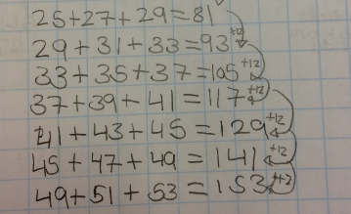
You then asked us to think about why the totals were odd and why they were multiples of 3.
Oliver, Radu and Krystian explained the odd totals like this:
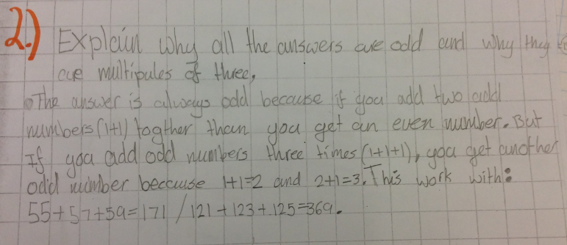
Rocco, Gordon and Ethan explained like this:
‘If you add 2 odds you will get even, if you add 2 evens you get even. If you add 3 odds you get odd because odd add odd is even, then add another odd is odd.’
They also noticed that when you divide the total by 3 you get the middle number.
Leila and Immy continued to investigate this in a very colourful way!
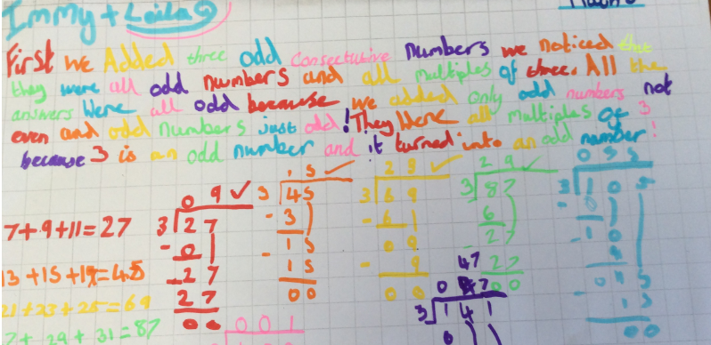

Grace and Elsie noticed that if you add the first and third number, this is double the middle number.
They showed this on a diagram – they also tried the same with three even consecutive numbers.

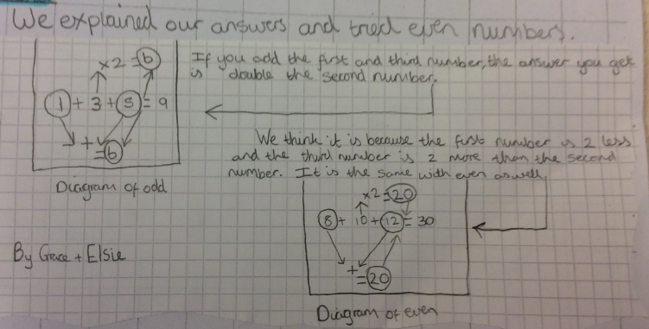
This was made really clear when you used the multilink cubes to demonstrate.

We had already started to ask questions and take our investigations in different directions.
Oliver, Radu and Krystian looked at what happens when you add five even consecutive numbers.
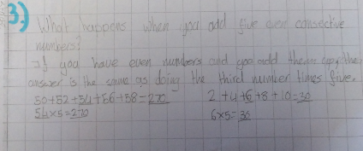
Grace and Elsie tried adding 3 even consecutive numbers. Skye also noticed that her totals from adding even numbers were all multiples of 3, 6 and 12.

Ethan tried adding 5 consecutive odd numbers and then 4
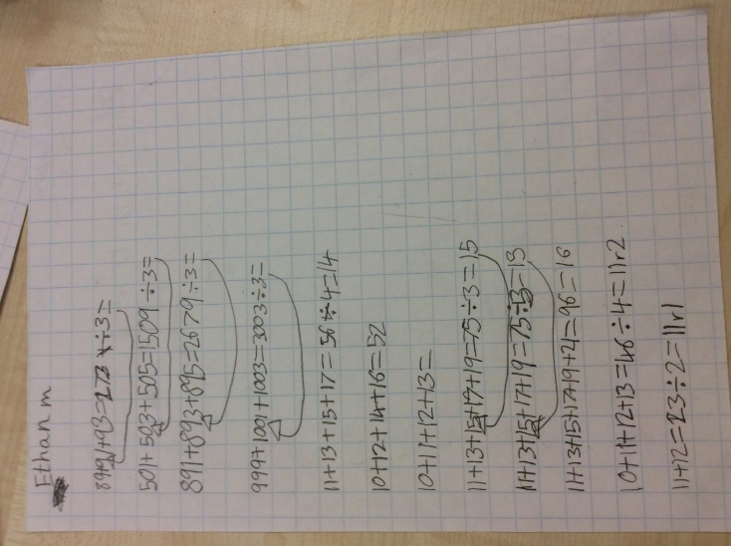

Frida and Jake continued to investigate the pattern in the totals.
Jake tried adding three other multiples together and looked at the totals
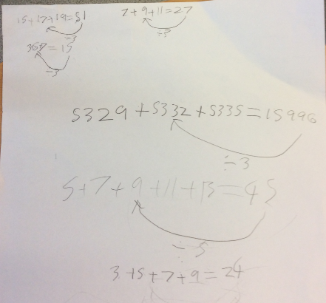
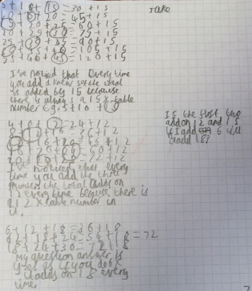
Rocco tried some bigger numbers.

Frida continued with consecutive odd and even numbers.
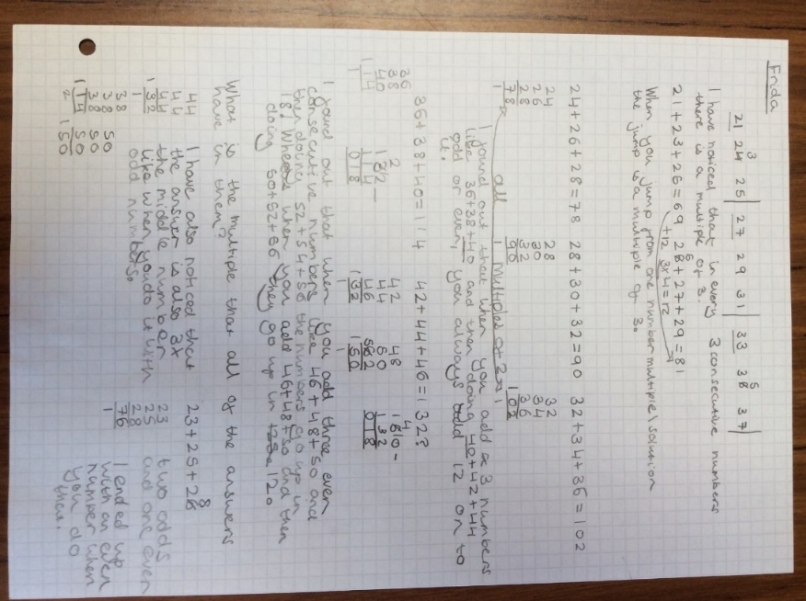

Thank you for the webinar. We all enjoyed taking part.

- - - - - - - - - - - - - - - - - - - - - - - - - - - - - - - - - - - - - - - - - - - - - - - - - - - - - - - - -
10/City International School, Balaganj India

Ankita: The total of three consecutive odd numbers will give a total which will be odd and a multiple of 3. eg 37+39+41= 117 3+5+7=15
- - - - - - - - - - - - - - - - - - - - - - - - - - - - - - - - - - - - - - - - - - - - - - - - - - - - - - - - - - - -

11/Eleanor Palmer School

Devansh: The three numbers must always be 1 more, 0 more and 2 more than a multiple of 3 so then this makes it balance out to a multiple of 3.

Luz: The first or second of the three numbers will always be either a multiple of 3 or one less than 3. Some are more, some are equal to and this balances it out.

Y4 group: Because the total was three times the middle number, we looked at why this happened. If we call the middle number x, then the first number is x-2 and the third
is x + 2. The -2 and +2 cancel each other out and leave 3 times x! We drew this out in cubes and redistributed the cubes to leave 3 3 and 3. We think this would happen with three consecutive evens or any 3 consecutive numbers. We think with 5 consecutive numbers it would total a multiple of 5 because you have the same thing with the middle number. We think 4 wouldn't work!
- - - - - - - - - - - - - - - - - - - - - - - - - - - - - - - - - - - - - - - - - - - - - - - - - - - - - - - -

12/ Cubitt Town Junior School
Miss Whitwam: The answers are always odd because when you add two odd numbers e.g 3, 5 the answer is always even ( 8). However, when you add another odd number e.g 7 the answer becomes odd again (15). That is always the rule.
We have noticed that in 5 consecutive numbers that the middle number still multiplies to give the answer. e.g 1,3,5,7,9= 25 5 x 5 = 25
We also looked at 3,5,7,9,11 = 35 7 x 5 = 35
We also looked at 7 consecutive numbers 1 3 5 7 9 11 13 = 49 7 x 7 = 49
So, we think that the number of numbers multiplied by the middle number always gives us the answer.
- - - - - - - - - - - - - - - - - - - - - - - - - - - - - - - - - - - - - - - - - - - - - - - - - - - - - - - - - - -

13/ Edna G Olds Academy

Year 6: The totals are all odd because the total is essentially the middle odd number multiplied by 3. Multiplying an odd number by 3 will always result in an odd answer.
In sets of 4 odd numbers, we noticed that the totals are all even and multiples of 4. This is because the number between the 2 middle numbers when multiplied by 4 makes the total.
- - - - - - - - - - - - - - - - - - - - - - - - - - - - - - - - - - - - - - - - - - - - - - - - - - - - - - - - - - -

14/ Graveney School
Vanessa noticed that if you add three consecutive even numbers it is not an odd total it is an even total.
Matilda looked at the sums as a sequence and noticed a pattern in the remainders when divided by nine.
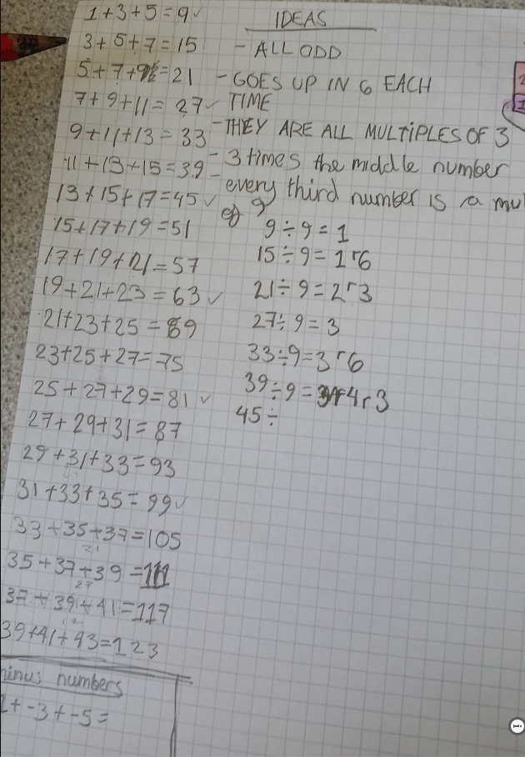

- — - - - - - - - - - — - - - - - - - - - - - — - - - - - - - - - - - - - - - - - - - - - - - - - - - - - - - -

15/ Hardingstone

Harry: 3 odd numbers added together make an odd number because there is always 1 extra that cannot be paired up. The even numbers in the 3 times table are missing from the answers. It's add 6 each time to the previous answer if following a system. 6 is a multiple of 3.
5 consecutive odd numbers goes in tens middle number times by 5 each time
- - - - - - - - - - - - - - - - - - - - - - - - - - - - - - - - - - - - - - - - - - - - - - - - - - - - - - - - - - -

16/ Harmans Water

5EW: If you add any 3 consecutive odd numbers together you will always end up with and odd number.

Whenever you add 2 odd numbers together you always get an even number and when you add an odd number and an even number you will always get an odd number. There for whenever you add 3 odd numbers you will always get an odd number.
- - - - - - - - - - - - - - - - - - - - - - - - - - - - - - - - - - - - - - - - - - - - - - - - - - - - - - - - - - - -

17/ Holy Trinity Pewley Down

Max

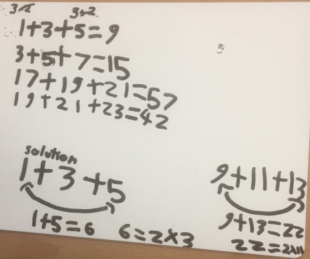
- - - - - - - - - - - - - - - - - - - - - - - - - - - - - - - - - - - - - - - - - - - - - - - - - - - - - - - - - - - -

18/ Harmanswater Primary

5T:

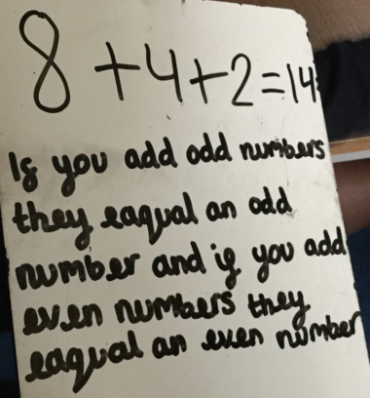
- - - - - - - - - - - - - - - - - - - - - - - - - - - - - - - - - - - - - - - - - - - - - - - - - - - - -

19/ Horringer Court

Year 6: Odd + Odd =Even so Odd + Odd + odd= Odd Therefore the answers will always have to be odd. 3 consecutive numbers. Take the end number, take off the jump they are going up in (2), add it to the first number to make all the numbers the same. For 4 consecutive even numbers: Total the 2 middle numbes, double it this give the same answer as the total of the 4 numbers.
For odd consecutive numbers: However many numbers you use, multiply it bythe middle number and that will always give your total.
For totaling 5 odd consecutive numbers, it will always end in a 5.
- - - - - - - - - - - - - - - - - - - - - - - - - - - - - - - - - - - - - - - - - - - - - - - - - - - - - - - - - -

20/ Lansbury Lawrence

Riley Class: We explored 5 consecutive odd numbers and multiplied the middle number by 5. We found it gave us the same answer as when we added them together. We then explored this with 7 consecutive odd numbers and multiplied the middle number by 7 and got the correct answer.
When we add three consecutive even numbers together we noticed you can also multiply the middle number by 3. When we continued the pattern and added consecutive even numbers in 3's, we noticed that if we added 18 to the totals, we would find the total for the next consecutive numbers.
2 + 4 + 6 = 12 8 + 10 +12 = 30 14 + 16 + 18 = 48 Each total has a difference of 18.
We also added four odd consecutive numbers together and multiplied the
middle number by 4 to get the answer. For example, 3 , 5 , 7, 9. The middle number would be 6 because that is between 7 and 9. 4 x 6 = 24. 3+5+7+9= 24. We are working out why.
- — - - - - - - - - - — - - - - - - - - - - - — - - - - - - - - - - - - - - - - - - - - - - - -

21/ Mawsley CP School
Danny:
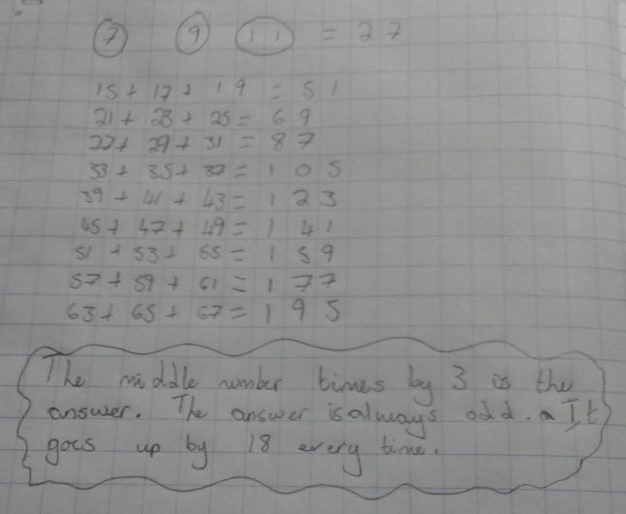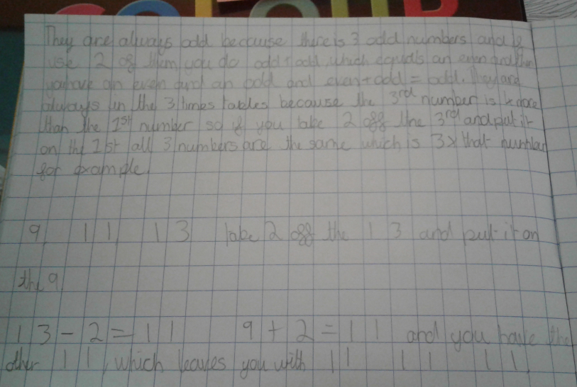

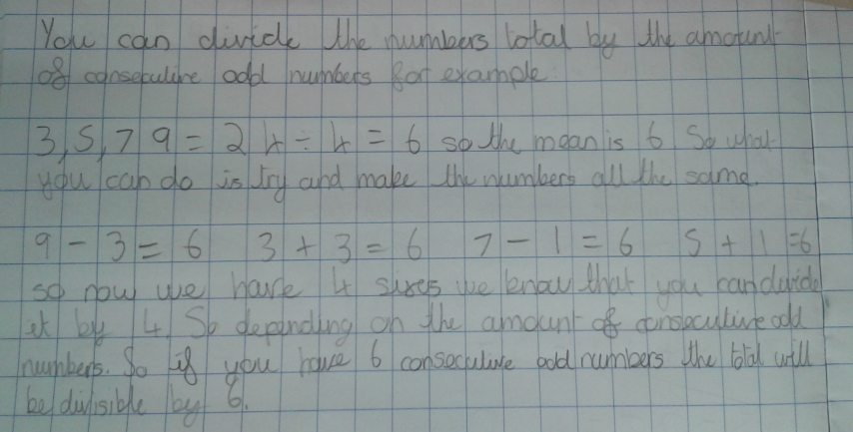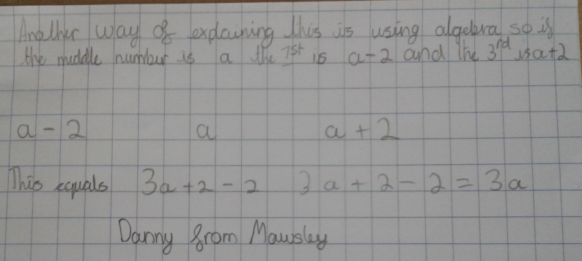

Ewan and Frazer
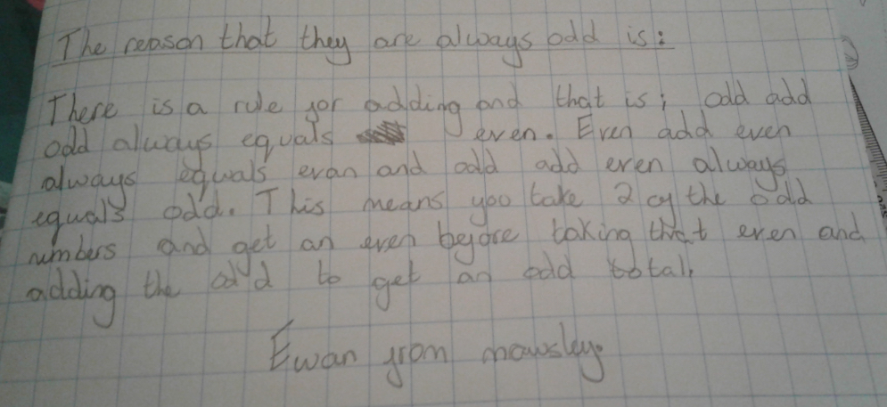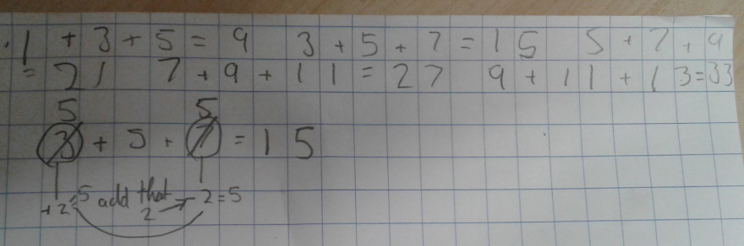
- - - - - - - - - - - - - - - - - - - - - - - - - - - - - - -

22/ Millfield L.E.A.D. Academy
Isaac: The numbers are always odd: 2 odds always make an even; however, if you add another odd number, the answer becomes odd.

Miss Evans' Class:We notice that if you add 3 odd OR even consecutive numbers, the answer is a multiple of 3.
We noticed that with however many numbers there are in the set, the answer will be a multiple of that number. For example, if there are 2 consecutive odd numbers, the answer will be a multiple of 2. If there are 5 consecutive odd numbers, the answer will be a multiple of 5.

Dylan: If you have 3 even consecutive numbers, you can just times the last number in the sequence by 2 to get your answer.

Anu: To find the total of 4 consecutive odd numbers, you can do the amount of numbers in the set x the median of the set of numbers.
- - - - - - - - - - - - - - - - - - - - - - - - - - - - -

23/ Malton School
We have noticed that the 3 numbers always add to an odd number because odd + odd = even and even + odd = odd.
Also, the sum of the three numbers is 3 times the middle number. The middle number is therefore the average of the 3 numbers.
If you add together 3 even numbers, you will always get an even. even+even = even
The answer is still always still the middle number multiplied by 3. There is a pattern in the solutions for the even numbers. If the first number = x
You have: x + (x + 2) + (x + 4) = 3x + 6 = 3(x+2)
Therefore, always in 3x tables
- - - - - - - - - - - - - - - - - - - - - - - - - - - -

24/Marner Primary
6S: We’ve realised that the difference between the middle numbers is always 6. We know that if you add 3 odd numbers, you always get an odd number but take 4 odd numbers and you’ll get an even number and the pattern continues... Busy still investigating :)
- - - - - - - - - - - - - - - - - - - - - - - - - - - - -

25/ Olga Primary
Denniston: Question on adding 5 odd numbers:
If you add an odd amount of consecutive odds you get an odd answer but if you add an even amount of consecutive odd numbers you get an even answer.

Martina: The reason to why it is always odd is because an odd and an odd makes an even but an odd and an even makes an odd so an odd, odd and odd will make a odd for example 1+3=4 that is an even number 2,4 1+3+5=9 that is an odd number 2,4,6,8,10

Joshua: no matter what when you do 2+4+6=12 but half of 6 is 3 and when you do
4-1=3 and the left over 1+2=3 so basically that's why its the same as it
would be like with a odd number you just done 3x4=12

Lizzy: Two consecutive odd numbers added is an even number because you are adding
(2 is even) so if you add an odd number of consecutive odd numbers your answer is odd.
I found out that if you add consecutive 3 odd or even numbers the difference between the answers is always 6. For example:
1+3+5=9 3+5+7=15 the difference is 6 2+4+6=12 4+6+8=18 the difference is 6.

Yasin: My numbers are always 12 apart. 9, 21, 33, 45, 57
I noticed that if you add three even numbers systematically you get an answer of a multiple of six .An example 0+2+4=6 2+4+6=12 4+6+8=18

Stella: I've only started working out why all the answers had a difference of six. But I found out that every four sequences in all three numbers there is a difference of six. Maybe this might help other students who are trying to solve this close-to-impossible question.

Ebrahim: I found out that that if you add 2 to odd or even number it makes and odd
or even number again, for example : 27 (odd ) + 2 = 29 (odd). 32 (even) + 2 = 34 (even) . Also, another thing I have noticed is that the numbers have a difference of 6. e.g 1+3 = 9 3+5+7= 15 5+7+9= 21
Also, another thing I have have noticed is that the numbers have a difference of 6.
e.g 1+3 = 9 3+5+7= 15 5+7+9= 21

Ayaan: I found out that when you done all of the first questions you guys asked us
to do they all ended up in the three times table.

Juwayriya: I think if the middle number is even then the answer is even,sometimes,for
example:17+12+13=42 and same with odd 6+5+4=15

Fahmida: If the middle number is odd the answer is gonna be odd for example
6 + 5 + 4 =15 and same with even 5 + 4 + 3 = 12.

Ibrahim: 1+3+5=9 3+5+7=15 5+7+9=21 7+9+11=27 9+11=13=33
I found out that it goes up in sixes starting from the 9

Louis: What Happens When You Add Five Odd Numbers: When you add 5 odd numbers together the middle number always is the answer times by 5 i think this is because with each time the two numbers before taking away 4 and the 2 after adding four cancelling out the 4 before so you end up with the answer.
- - - - - - - - - - - - - - - - - - - - - - - - - - - - - - -

26/ Orchard Academy
Mrs Turvey: All answers are odd and multiples of 3
When adding 5 odd numbers, the answer always ends in 5

Oak Class: We noticed: all the totals are odd; The difference between two sets is a multiple of 6; The difference between two sets is an even number
- - - - - - - - - - - - - - - - - - - - - - - - - - - - - -

27/ Plantation Primary
Hanna: I noticed that when you add the first 2 numbers in each consecutive odd number sequence the total will be divisible by 4.

Kenzie: We know that odd add odd equals even, but when you add another odd number it equals odd, because odd add even equals odd!
When you add three consecutive even numbers the middle number is multiplied by 3 to give your answer, and the consecutive answers go up in 12s.

Dylan: Every time you have three consecutive odd numbers they go up in 2s, and because there are three differences of two, you do 3 x 2 = 6 and 6 x 3 = 18 which explains the difference of 6 each time

Harvey: They are 3 times the middle number because the two either side are 2 less and 2 more than the middle so if you take away two from the bigger number and add that to the smaller number then you get the middle number. Then you are multiplying the middle number by 3

Cayden: When you add five consecutive odd numbers, the answer is 5 times the middle number

Lily: I noticed that when you add five consecutive odd numbers the answers always end in a 5
Adding three even numbers is still a multiple of 3 as the same as the concept is still the same
- - - - - - - - - - - - - - - - - - - - - - - - - - - -

28/ Redwood Bishops Down
When you add 5 consecutive odd numbers the answer is the middle number x by 5.
- - - - - - - - - - - - - - - - - - - - - - - - - - - - - - -

29/ Saxon Primary
Mr Howick: All the answer are in the 3 times table. All the numbers in each answer are odd. Each consecutive group goes up by 18 e.g. 3,5,7 = 15 9, 11, 13= 33
The consecutive number all go up by 18. 18 is in the three times table so all of the products will be multiples of 3 'Tommy 5H' . Daisy 5H 'all of the answer are in the three time stable'

Caitlin: All my answers are multiples of 3.

Oliver: Consecutive odd numbers explanation. When you add an odd number plus an odd number, It will equal an even number. But an Even number and an odd number you get an odd number. However, many consecutive even numbers you have, the answer will always be an even number. This is because an even number plus an even number will always equal an even number. That is my point for no matter how many consecutive even numbers you add together, the answer will always be an even number.

Jacob: Problem: Adding 3 consecutive odd number explanation. When you add 3 consecutive even numbers the units always go 2,8,6,4,2,8,6,4.

Liam: Two of the numbers added together create a multiple of 3 and one of the consecutive numbers is already a multiple of 3.
e.g. 7,9,11 7+11= 18 which is a multiple of 3 9 already is a multiple of 3

Florence and Alfie-Jack: When you add 2 evens and odd you will always have an even number.

Emily: If you add 3 odd numbers together you create another odd number.

Tom: When adding 3 multiples of the 4 times table, you will always have an answer that is also in the 4 times table.

Evie: When you add three even numbers together you have a even number. If you add 2,4 and 6 you get 12 and when you have 4,6 and 8 you have 18 so they are going up in 6s like when you have 3 odd numbers.

Zayne: 5 Numbers ends in the 5x table

Jacob and Nicolas: when you add 5 consecutive odd numbers your answers go up in tens and
always end in 5 for example 1+3+5+7+9=25

Florence: When adding 4 odd numbers you will always get an even number . I also
noticed that my answers are all multiples of 8 . For example 1+3+5+7=16 and
3+5+7+9=24 .

Rathik: If you do addition with an even amount of odd numbers, your answer will be
even .

Nicolas: if you add 5 even numbers your answer will be a multiple of 10

Marcus: I noticed that in even groups of five consecutive the answer is always a
multiple of ten.
- - - - - - - - - - - - -- - - - - - - - - - - - - - - - -

30/ Scoil Bhríde Buachaillí Ireland

Ms Sneyd's 4th class: Our class discussed lots of ideas but Daniel was really good at explaining his own theory...
For example:
A) 3+5+7+9 = 24 is four consecutive odd numbers added together
B) 3+5+7+9+11 = 35 is five consecutive odd numbers added together
C) 3+5+7+9+11+13= 48 is six consecutive odd numbers added together
D) 3+5+7+9+11+13+15= 63 is seven consecutive odd numbers added together

Daniel thinks that if we add together an even number (ie 2 or 4) of odd consecutive numbers together like in A or C, we will get an even answer. If we add together an odd number of odd consecutive numbers like in B or D we will get an odd answer.
Files: NFB14K-IMG_1077.jpg
- - - - - - - -- - - - -- - - - - - - - - - - - - - - - - - - - - - -- - - - - - - - - - - - - - - - -

31/ St Christopher’s Bahrain
Grace: Observations
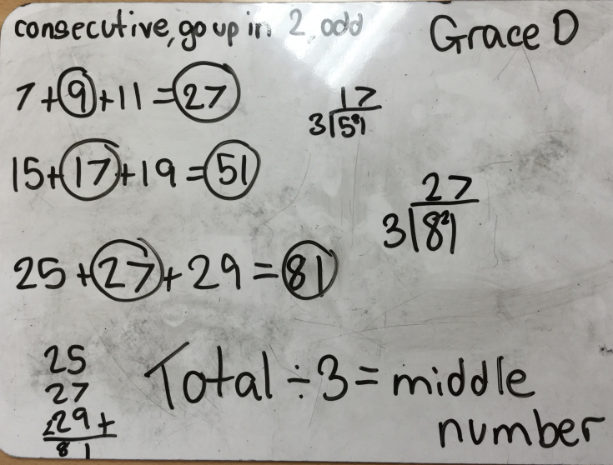

Zara, Rizni and Mia Observations:
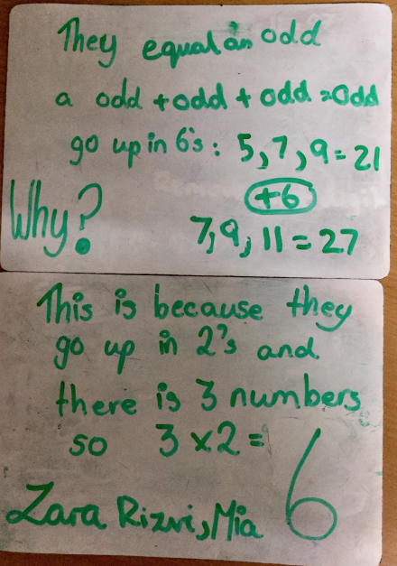

Grace and Ashlyn 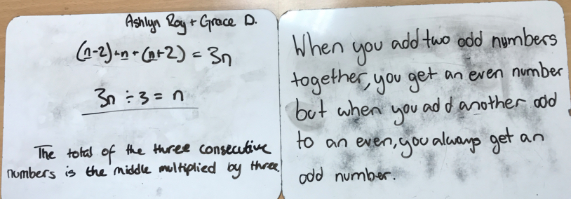

Maddie: Algebra
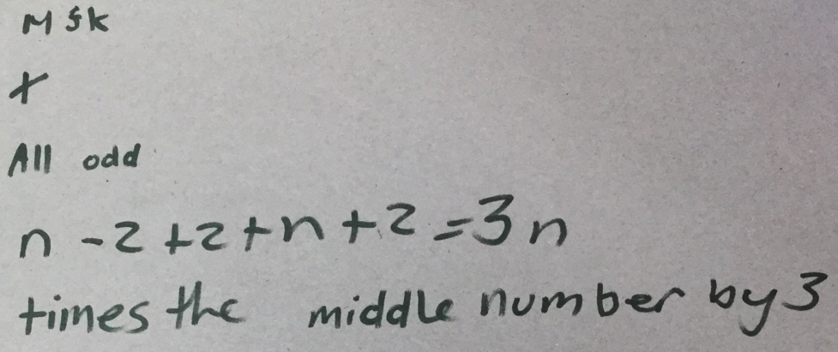

This is my solution to how ODDs and EVENs are NOT different in the problem of house numbers.
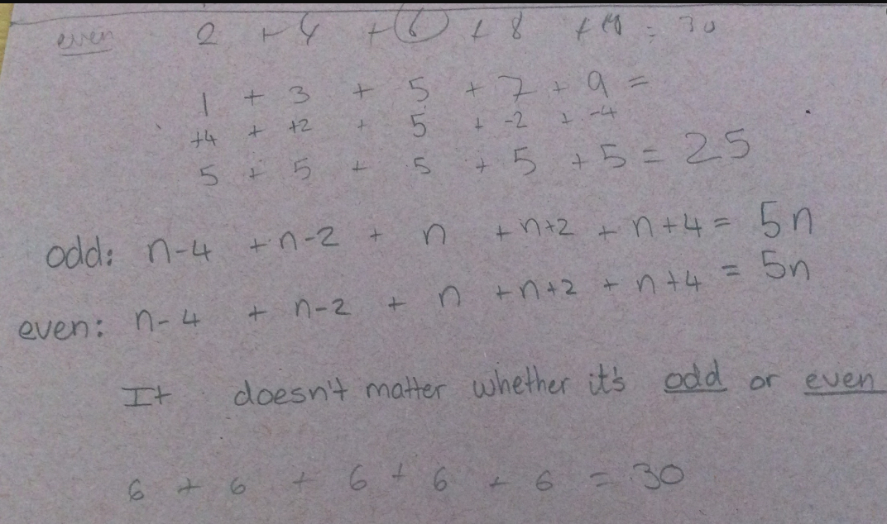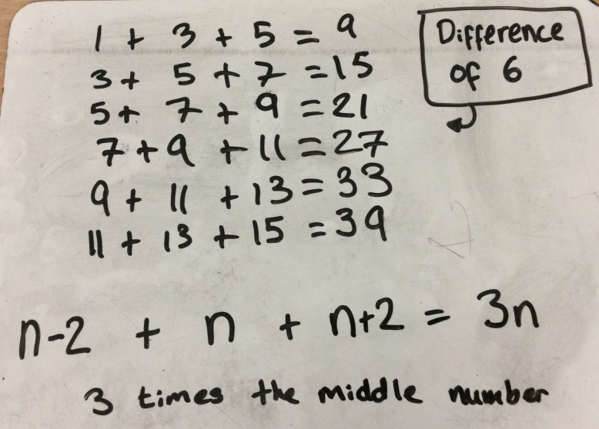

Kiera and Thomas
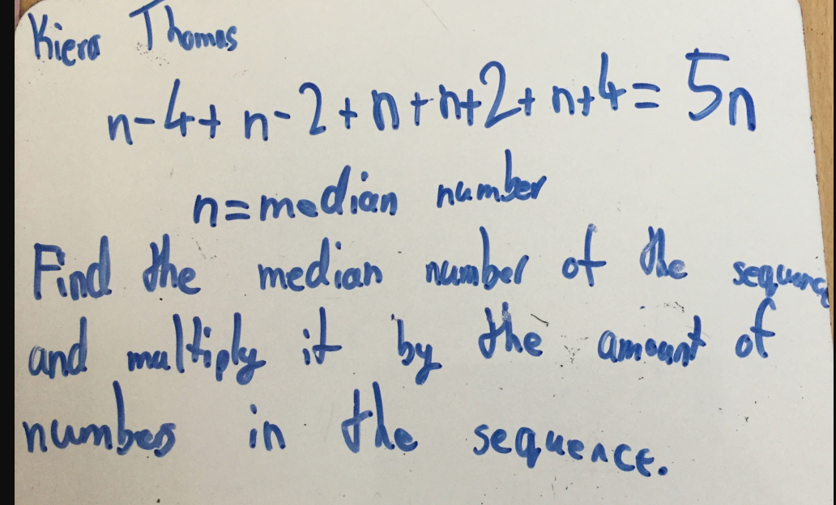

Grace and Isabel AND Adam and Zouheir:

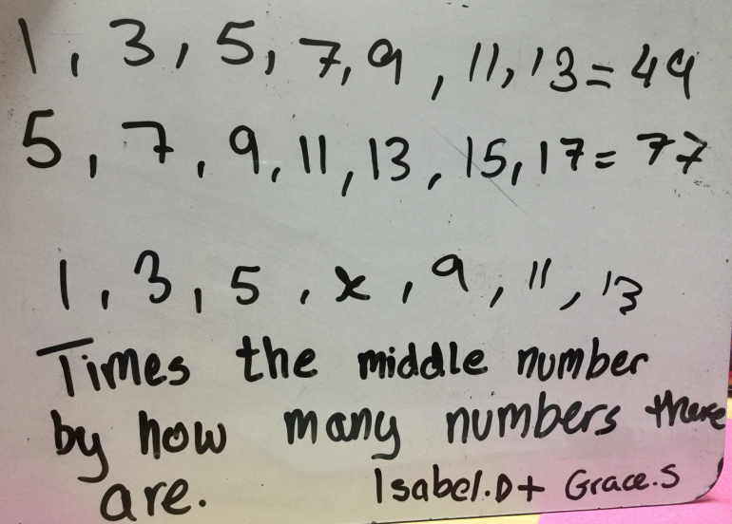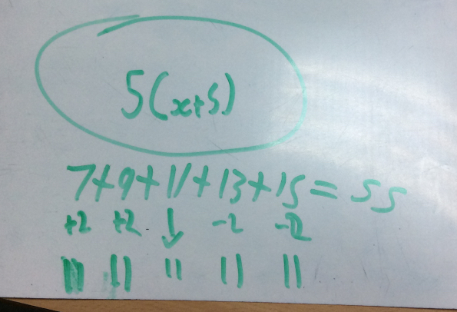
Lawrence: Four consecutive number sequence problem: Example: (n-2) + n + (n+2) + (n+4) = y; y = 2(n + (n+2)): 13 + 15 + 17 + 19 = 64: 15 + 17 = 32: 32 x 2 = 64
Kiera: To find the sum of the numbers in the sequence (of consecutive numbers), you have to find the median number of the sequence and multiply it by the amount of numbers in the sequence. Algebra equation to prove (using 5 consecutive odds): n-4+n-2+n+n+2+n+4=5n
(n=median number)

Sascha: To find the sum of the numbers you have to multiply the middle number by 3.
You can use the nth term to use algebra if you want to find the answer by doing it that way. You can use the same expression when you want to find if it works with 4 numbers or consecutive numbers with difference that are higher or lower than 2.
Sascha AND Siddarth:

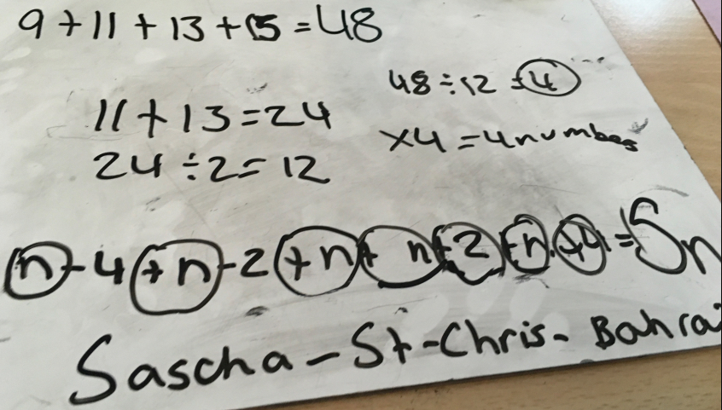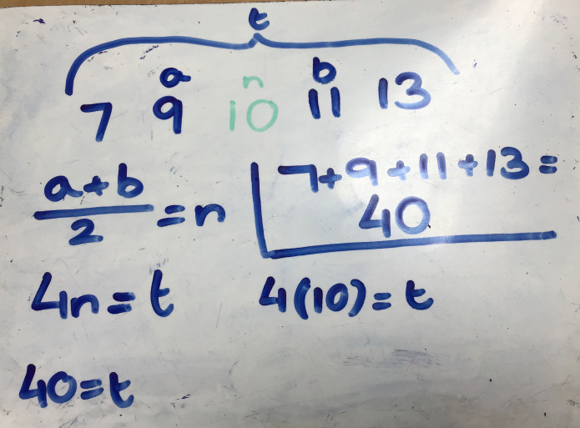
Mia:
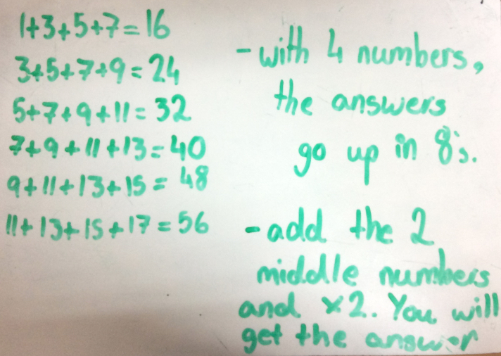
Jeremy: This shows how to work out the total for any amount of numbers in asequence. The first number is the amount of numbers in the sequence, x is the first number and the rest says what to do.
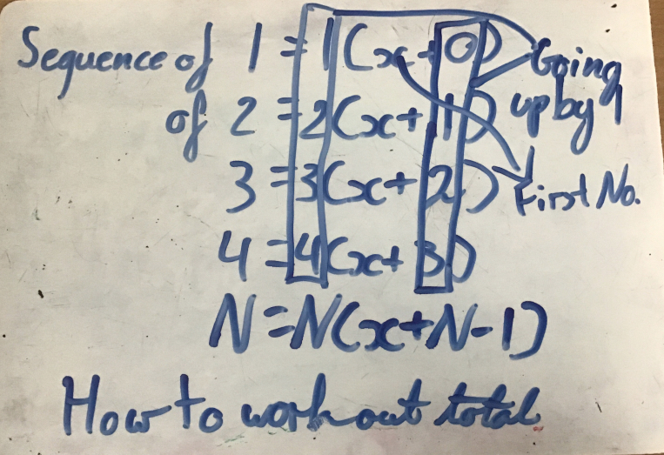

Asad: I have an answer for consecutive even numbers. I have found that when you
add the numbers together it goes up in 4’s.

Also, I have discovered that to find the total of $ consecutive even numbers, you must use the same rule as with odd numbers, multiply the middle number by three. I have explained my answer algebraically.

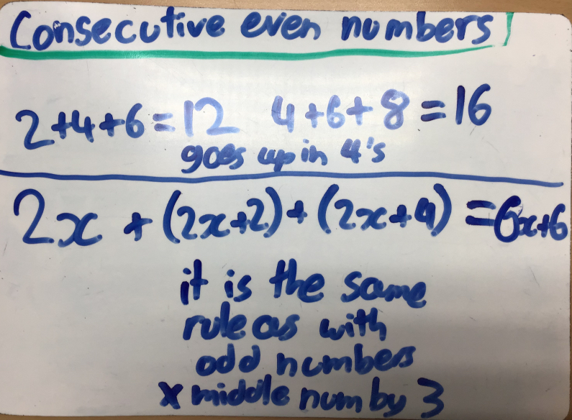

Alex and Vish
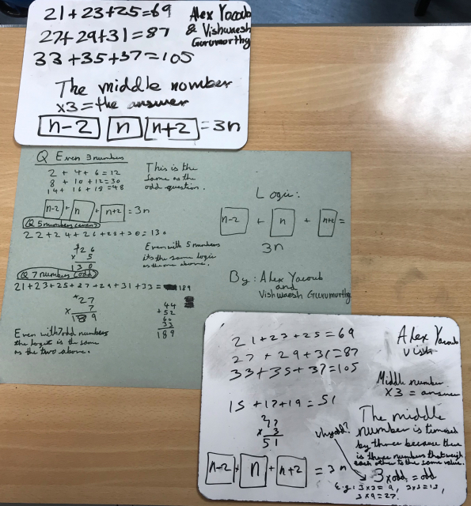

Alvic AND Sophie
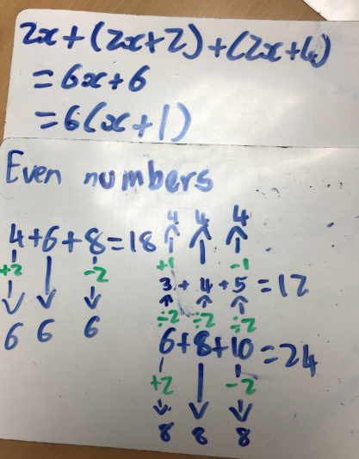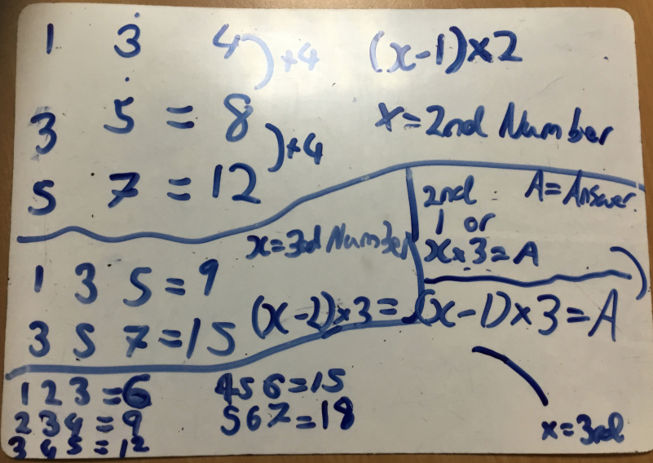
- - - - - - - - - - - - - - - - - - - - - - - - - - - - - - -

32/ St Laurence
Els: If you multiply the middle number by 3 - that gives the total of the 3 consecutive odd numbers.

Daniella: With 3 even consecutive numbers - the total is always the middle number multiplied by 3 too!

Dylan: 3 even consecutive numbers will always total to the middle number multiplied by 3 and will always be even.

Ryan: When you have 5 odd consecutive numbers - multiply the middle number by 5
and you will get the the total of the 5 numbers.

Ellie: If you times the middle number by the amount of odd consecutive numbers you
have, you will always get the total. This works with even numbers too!
- - - - - - - - - - - - - - - - - - - - - - - - - - - - - - - -

33/ St Nessans
Your answer is always an odd number

Amisha & Adam: We noticed that the answers are all multiples of 3

5th class: Ciara noticed if you divide your answer by 3 you always get the second number

Ms. Moloney 4th Class: If you add an odd number of odd numbers you get an odd number, however if you add an even number of odd numbers you will get an even number

Aaron 5th class: odd + odd + odd = odd ( 3 numbers)= multiples of 3; odd + odd + odd + odd + odd = odd ( 5 numbers) = multiples of 5

Antoni: If you add two odd numbers you will always get and even number. If you add one more odd number the answer will be an odd number. Eg: 1+3 =4 1+3+5=9 3+5=8 3+5+9=17

Adam and Emily: 2 evens = even 3 evens =even.
Answers go up in sixes Eg: 2+4+6= 12 4+6+8= 18 Middle number x 3= answer
- - - - - - - - - - - - - - - - - - - - - - - - - - -

34/ Stimpson Avenue
Miranza: I noticed that when I add the following consecutive numbers, the answer always ends in a 5 and is a difference of 30:
13+15+17 = 45 23 +25 + 27 = 75 33 +35 + 37 = 105 43 +45 +47 = 135

Liam: For every increments of ten, the answer is increased by 30. Eg: 69 + 71 + 73 = 213
79 + 81 + 83 = 243 89 + 91 + 93 = 273
This is because 3 x 10 = 30 so the answer will always increase by 30

Fahim: I found that when you add 3 consecutive even numbers, you always get an even number.
- - - - - - - - - - - - - - - - - - - - - - - - - - -

35/ Tudor Grange Primary Academy St James
Saveena: If you add 3 consecutive numbers together they will add up to an odd number and the answers are multiples of 3.

Saira AND Saleema


                                                           

