Nine Colours

http://nrich.maths.org/768

You have 27 small cubes, 3 each of nine colours.

Use the small cubes to make a 3 by 3 by 3 cube so that each face of the bigger cube contains one of every colour.

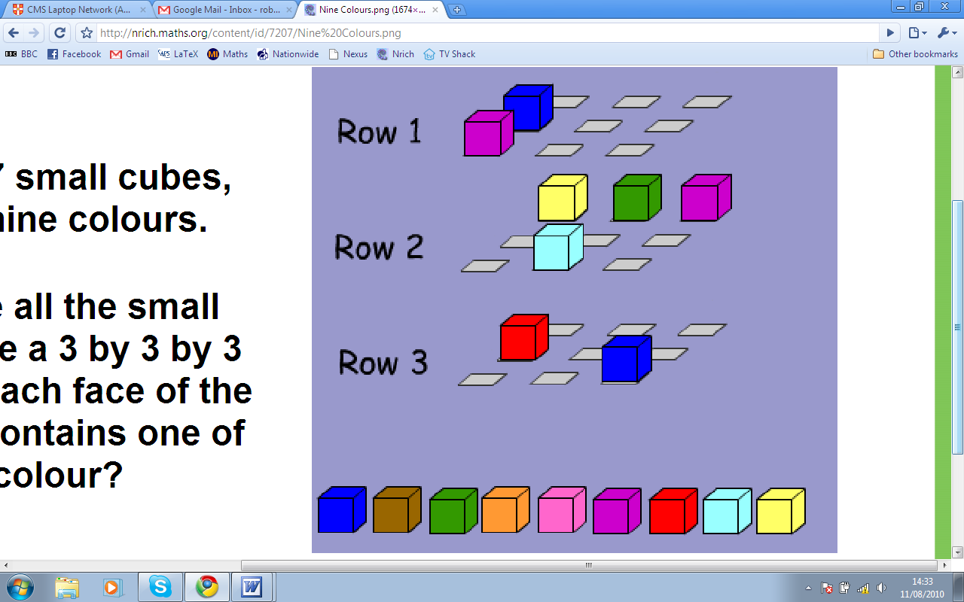

You Will Need:
- 27 interlocking cubes, 3 each of 9 colours

Teachers’ Notes

Why do this problem?
This is an engaging problem that challenges students to work in 3 dimensions and to use different representations of the cube. It can be used to encourage students to persevere, collaborate, work systematically and reason logically.

Possible approach
Introduce the task by challenging the students to create an anti-rubik's cube.
Offer them multilink cubes (plastic coloured cubes that fix together), pencil and paper and the computer interactivity so that they have a choice of ways in which to approach the problem.
Let students pursue their own attempts to orientate themselves within this context, but attention may be drawn, at well-judged moments, to the number of faces that cubes in individual positions will have 'visible'.

Key questions
Some of the 27 cubes have faces that are invisible from the 'outside' of the large cube. How many cubes have no 'visible' faces? One face visible? Two faces visible? Three faces visible?
If one colour appears in a corner, where will the other two cubes of the same colour need to appear?
There will be a cube of some colour at the centre. Where else will cubes of that colour need to be positioned?

Possible extension
If students have chosen how to solve the problem from a range of possibilities (ie. multilink cubes, pencil and paper or the computer interactivity) challenge them to solve the puzzle again from scratch using a different approach.

Possible support
Students could attempt “Painted Cube” before trying this problem.

