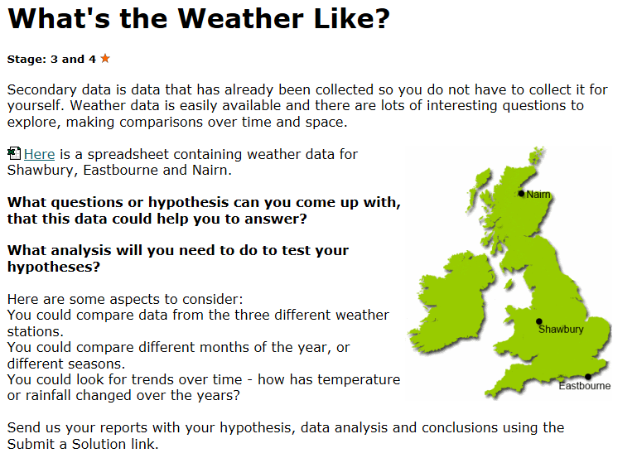

What’s your Hypothesis?
In January, the further down south you are, the more hours of sunlight there will be.
How will we test our Hypothesis?
Our plan is that we shall collect data of each January from 1960-2000 for each area in the United Kingdom. With that data we shall explore what area had the most hours of sunshine in January. We will average the amount of sun hours each 10 years and apply them to a graph so the data can be visualised.
What does our graph show?
This graph shows us that Eastbourne had the most areas sunshine in January each year from 1961-2000. This graph also shows up that from 1971-1980, the hours of sunshine in Eastbourne and Shawbury rose but the sunlight hours in Nairn didn’t. The area of Nairn seemed to have risen in sunlight hours when the other 2 areas which were further south had less sunlight hours and when Eastbourne and Shawbury got more hours of sunlight, the hours of sunlight in Nairn dropped again.

Our results, what they show and whether or not they prove our thoughts and hypothesis right.

