GREEN: Punnet Squares
Below are all the possible attributes for plants. The capital letters means it is dominant and a small letter means it is recessive.

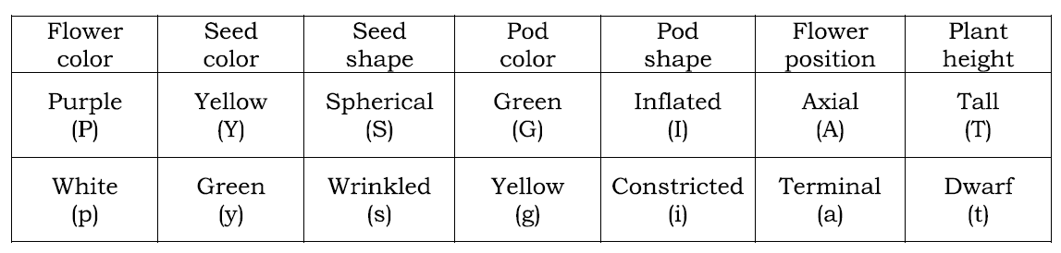
- GG x Gg
G
G
GG
G
g

- aa x Aa
a
a

- Ss x Ss

- yy x yy
- PP x pp
- Draw a punnet square.

- What is the probability that the offspring plants will be purple? How many will be white?
- tt x Tt
- Draw a punnet square.

- What is the probability that the plant will be tall? What about dwarf?

Draw a punnet square.

