- What were the ‘rules’?
- What did you notice?
- What did you predict?
- What did you discover?
- What did you wonder?

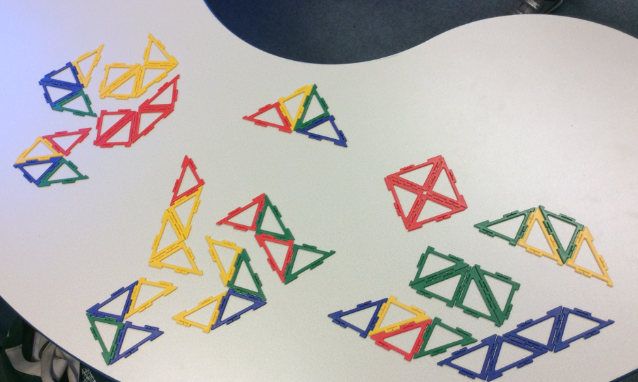
The rules were that the shapes had to connect with the same length side as another shape and each shape we made with 4 triangles had to be unique.
- We noticed that a lot of the shapes were square based although we’re not sure if we found
all of these (8 ) and some were parallelogram based (5) Some were both and we got confused as to how we should group them.
- We noticed there were 5 quadrilaterals
- We found 1 triangle
- We found 6 hexagons
- We found 2 pentagons
We predicted that we could have found more, but lots turned out to be doubles.
We discovered we couldn’t make any shapes with more than 6 sides. Amelie thought this was because as we’re using 4 triangles – only two sides or less can be part of the perimeter and 2 x 4 + 8. However, a shape must have at least 2 triangles where only one side makes up the perimeter or at least one triangle where none of the sides add to the perimeter. This takes away 2 sides of the perimeter leaving you with 8-2 = 6.
We wondered if there was a rule or pattern we hadn’t spotted as we are not convinced we have found them all!
Maya and Kyra 5F and Amelie 5B

