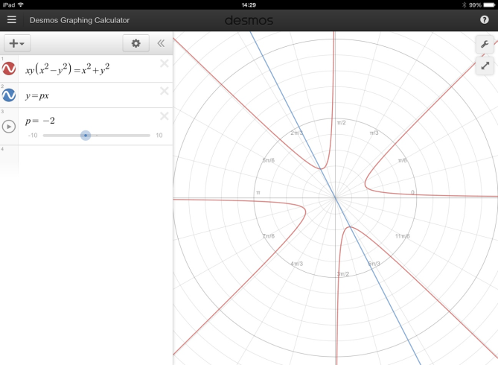
Maltese Cross Solution
We agree on most of the solution that has been written by Jim, however we have spotted a mistake for part (c).
In Jim’s solution he wrote that there is no intersection where $\left|p\right|>1.$ As you can see from the graph, if $p=-2$ there are two points of intersection even though $\left|p\right|>1.$
Below is our amendment to the solution.
We agree that $x^{2}=\frac{1+p^{2}}{p(1-p^{2})}$ and that there is no intersection where $x^{2}<0$. This means that $\frac{1+p^{2}}{p(1-p^{2})}<0$. $1+p^{2}$ will always be positive, therefore there are no points of intersection when $p\left(1-p^{2}\right)<0$ and this can be written as $p(1+p)(1-p)<0.$ As you can see from the cubic graph, this inequality holds where $p>1$ or $-1<p<0.$

